Chapter 7

Future modifications

Future modifications
7.1-Control system:

One of the main advantages of the wind cube is its ability to work inside towns, but the main problem that faced us was the turbulence and diversity of wind direction. The wind changes direction so frequently inside cities so it was very important to invent a way to rotate the cube in a circular motion to face the wind.

In homemade wind turbines a big tail is used to rotate the turbine, in ordinary wind turbines the nacelle is rotated by a yaw mechanism and control system, but in the wind cube neither the tail nor the yaw mechanism will work with us.
So it’s important for future modifications to utilize a control system to be able to sense the wind direction and speed, the sensor then will feed a PLC control system and rotate the mechanism circularly around the main bearing using a high torque electric motors.
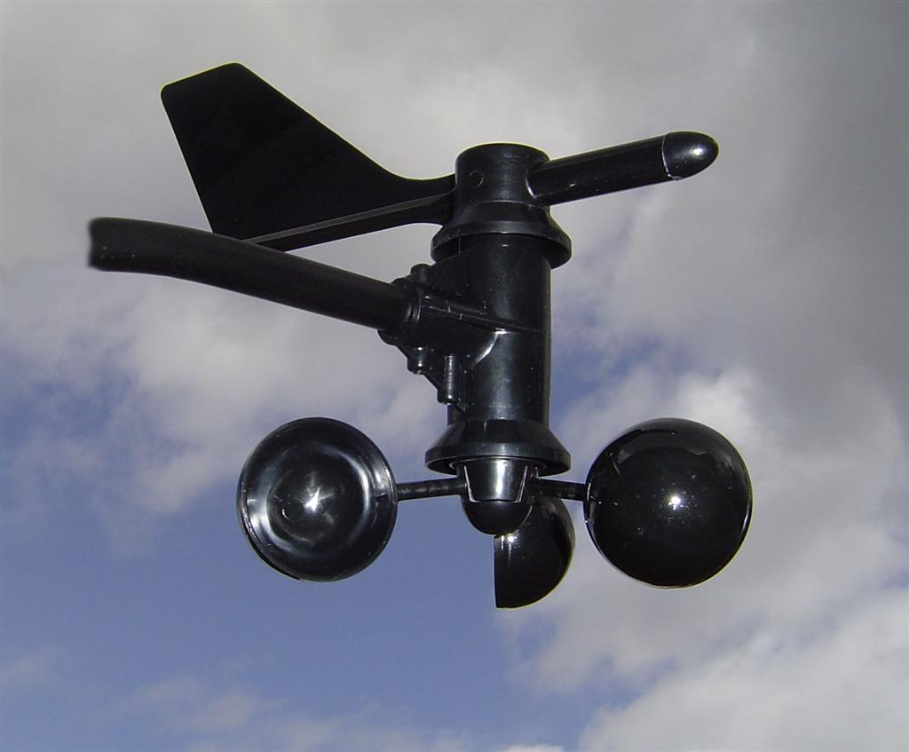

Wind speed and direction sensor

7.2-Safety system:
The safety system is purposed to protect the wind turbine and generator from over speeding which may break the turbines or burn the generator. if the sensors reads very high wind speed, the safety system will operate.
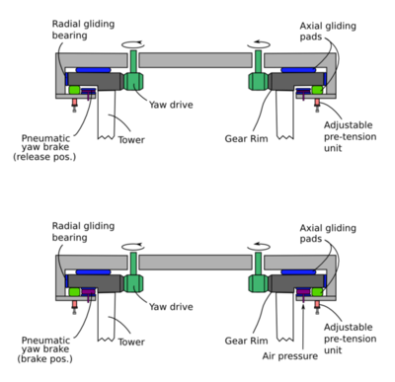
Brake system

You should note that braking the rotor suddenly would cause failure to the brake system or break the rotor, so stopping the turbine must happen on steps, at the beginning the pitch control will rotate the blades to minimize the lift force, then the control system should rotate the whole mechanism (cube) in a direction away from the wind direction, Finally the brake will operate to stop the rotor.

7.3-Electric system:

For future modifications we would recommend and electric circuit consists of a blocking diode, battery, dummy load, electric inverter, charge controller, voltmeter and tachometer.

7.3.1 Blocking diode: to make the current go in one way to the battery and doesn’t go back to the motor/generator.

7.3.2 Battery: for charging the DC current easily. Please note that Car batteries are not suitable for wind turbine usage because they are not designed for continuous charging and discharging.

7.3.3 Charge controller: will keep track of the volt of the battery, if it’s too low the current will go to charge the battery and if it’s too high the current will go to the dummy load to protect the battery.

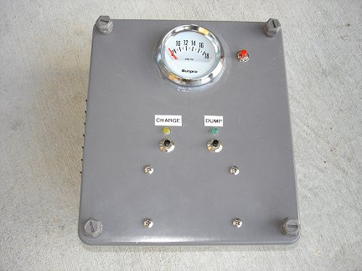

7.3.4 Dummy load: Is a kind if resistance to consume the extra current if the battery is fully charged.

7.3.5 Electric inverter: to convert the DC current AC current to be ready for instantaneous use.

7.4-Dealing with the torque problem:

When we designed our nozzle we was trying to minimize the nozzle outlet diameter to maximize the wind speed output, but this caused a serious problem which was a low torque output.
So in future modifications we would give bigger care to balance between the wind speed output and the diameter of the rotor to maximize the torque.

7.5-Nozzle on large scale:

When we manufactured our nozzle it was easy and more economical to make it from thin steel sheets, but if you wished to make it on a large scale this would be impossible because it will be very heavy and impossible to manufacture, so making the nozzle from fiber glass is recommended.

7.6. Adding scoop to the Tunnel
As power output is proportional to the cubic power of the incident airspeed, any small increase in the incident wind yields a large increase in the energy output

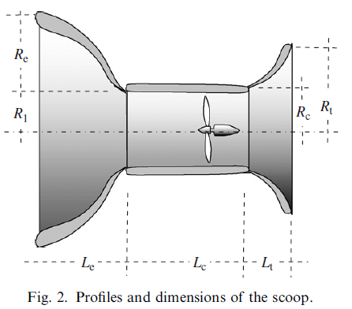

The scoop improves the power output of the wind turbine by accelerating the airflow in the cylindrical section. The scoop can perform well, providing a 2.2 times increase in mechanical energy than without a scoop.

The system contains a large diffuser with a flange creating a large separation in the flow. This generates a low-pressure region which assists the turbine in capturing more wind energy

From experimental research conducted on this system it is shown that a diffuser–shrouded wind turbine generates more power compared to a bare wind turbine, with a power coefficient four times higher .It is also shown that the downstream of the wind turbine the typical vortex structure created by a bare wind turbine is easily dispersed by the use of the diffuser, which is another feature that assists wind energy capture of the wind turbine. Other research groups have found that the wind speed in a diffuser is significantly influenced by the length and expansion angle of the diffuser and with an optimum design can create a wind speed improvement of 1.7 times

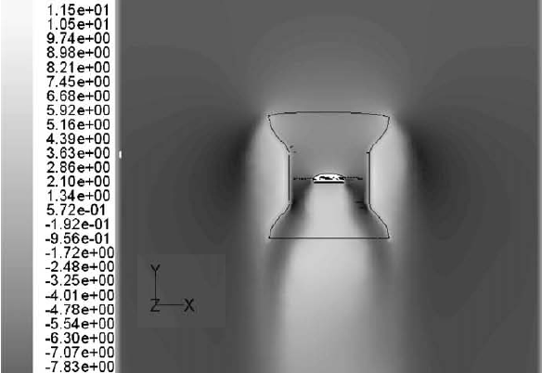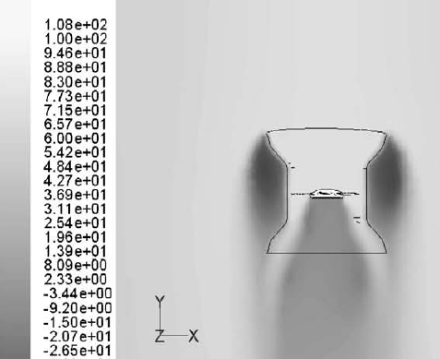

Contours of total pressure contours of axial velocity

